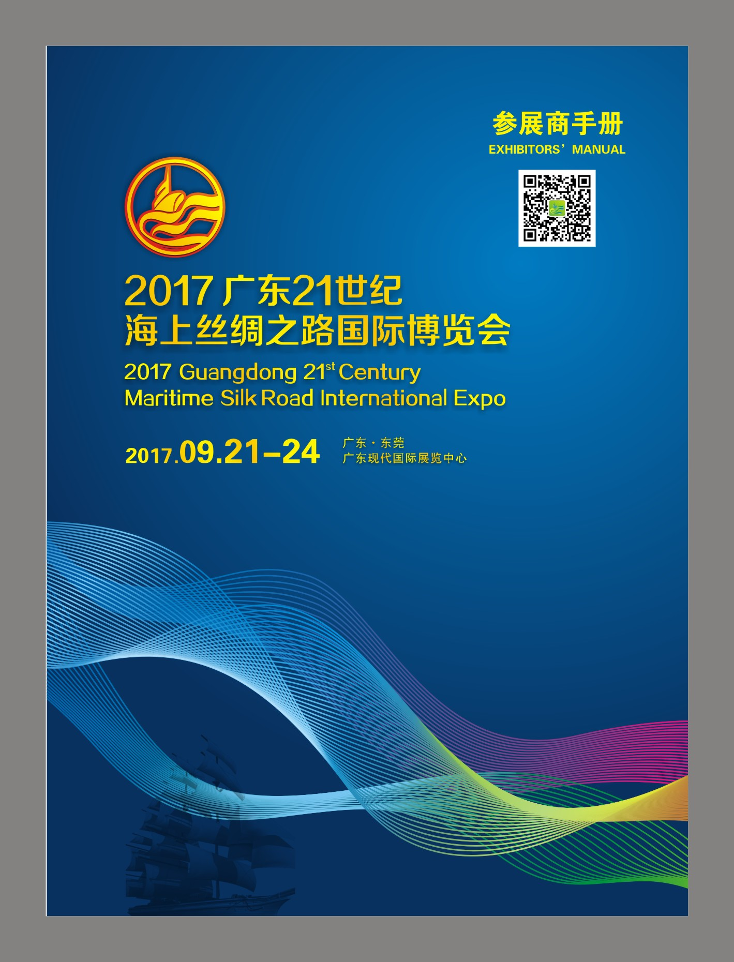
FOREWORD
Warm welcome is hereby given to the participating enterprises from countries and regions along the Maritime Silk Road to the 2017 Guangdong 21st Century Maritime Silk Road International Expo!
2017 Guangdong 21st Century Maritime Silk Road International Expo will be held in Guangdong Modern International Exhibition Center in Houjie, Dongguan City, from September 21 to 24, 2017. It is expected to set up one theme exhibition pavilion (consisting of three exhibitions, namely Business Opportunities Exhibition, Cross-border E-commerce Logistics Exhibition and Information Technology Products Exhibition) and six professional exhibitions, namely Exhibition of Tourism and Culture along the Maritime Silk Road, Exhibition of International Building Decoration Materials and Engineering Machinery, Exhibition of Typical Food and Agricultural Products along the Maritime Silk Road, Exhibition of Selected International Tea Culture, Exhibition of Selected International Ceramics Culture and Exhibition of Selected International Silk Culture.
Detailed information on and services provided by the 2017 Expo can be found in this Handbook. To ensure that you could receive our considerate and punctual supporting services and complete your work related to move-in, on-show and move-out of the Expo without difficulty, please read this Handbook through and provide relevant information to the Secretariat of the Organizing Committee in time as required.
Should you have any further question or demand, please do not hesitate to contact the Secretariat of the Organizing Committee and we will reply as soon as possible.

Best wishes to your successful exhibition!

Contents

Chapter I Introduction to the Expo…………………………………………………………P3-P5
Chapter II Introduction to the Exhibition Hall…………………………………………… P6-12
A1 Plan and External View of the Exhibition Hall and Forwarding Diagram……………… P6
A2 Transportation Guide …………………………………………………………………… P7-12
Article III Instructions to Exhibitors………………………………………………………… P13-16
B1 List of Forms for Exhibitors………………………………………………………………P13
B2 Instructions to Exhibitors…………………………………………………………………P14
B3 Regulations on Fire Safety……………………………………………………………… P15
Chapter IV Exhibition Stands ………………………………………………………………P16-26
C1 Basic Facilities of and Regulations on Standard Stands…………………………………P16
C2 Sketch of a Standard Stand………………………………………………………………P17
C3 Layout of Exhibition Stands (for Standard Stands) ……………………………………P18
C4 Lease of Exhibition Equipment ………………… …………………………………… P19
C5 Samples of Exhibition Equipment……………… ……………………………………… P20
C6 Instructions on Special Stand Construction……………………………………………… P21-22
C7 Construction and Decoration Contractor Application Form…………………………… P23
C8 Application for Lighting …………………………………………………………………P24
C9 Lighting Application Plan … …………………………………………………………… P25
C10 Extra Hour Charge…………………………………………………………………………P26
Chapter V Business Reception……………………………………………………………… P27-28
Chapter VI Translation Service………………………………………………………………P29
Chapter VII How to obtain an Exhibitor/Purchaser/Visitor Pass…………………………P30-31
Chapter VIII Exit and Entry Clearance Guide for Exhibits… ……………………………………P32-43

Chapter I Introduction to the Expo
1. Event
Guangdong 21st Century Maritime Silk Road International Expo
2. Venue
Exhibition Hall No. 1, No. 3 and No. 4, Guangdong Modern International Exhibition Center
Address: Intersection of S256 Provincial Road and Furniture Road, Houjie Town, Dongguan City, Guangdong Province, China
3. Organizational Structure
Sponsor:
China Council for the Promotion of International Trade (CCPIT), Guangdong Branch
Co-sponsors:
Guangdong Association of Enterprises with Foreign Investment (GAEFI), Guangdong Overseas Chinese Enterprises Association (GOCEA), Guangdong People’s Association for Friendship with Foreign Countries (GPAFFC), Guangdong Province Tourism Association (GPTA), Guangdong Cultural Industry Promotion Association (GCIPA), Guangdong’s Association for Promotion of Cooperation between Guangdong, Hong Kong & Macao (GAPCGHM)
Support Units:
China Council for the Promotion of International Trade (CCPIT), China Association of Enterprises with Foreign Investment (CAEFI), China Overseas Chinese Entrepreneurs Association (COCEA), The Chinese People’s Association for Friendship with Foreign Countries, China Tourism Association, China International Culture Association, China Association of Port-of-Entry, Hong Kong Trade Development Council (HKTDC), Hong Kong Tourism Board, Macao Trade and Investment Promotion Institute (IPIM), etc.
4. Supporting Services of the Expo
There will be a domestic sale service center established in the Expo venue where consulting service will be available to solve or deal with issues relevant to foreign trade and economics, customs, national tax, local tax, inspection and quarantine, quality control, commerce and industry, warehousing, logistics and so forth. In order to strengthen management of the Expo and fight against counterfeits and infringements, a Product Quality Surveillance and Complaint Service Center will also be established and relevant administrative departments, including quality & technology supervision, industry & commerce and intellectual property protection, will set up their temporary offices on the spot to cope with infringement of intellectual property rights and trademarks and other economic complaints.
5. Category of Exhibits
The 2017 Expo is expected to set up one theme exhibition pavilion (consisting of Achievements Exhibition, Business Opportunities Exhibition, Cross-border E-commerce Logistics Exhibition and Information Technology Products Exhibition) and six professional exhibitions, namely Exhibition of Tourism and Culture along Maritime Silk Road, Exhibition of International Building Decoration Materials and Engineering Machinery, Exhibition of Typical Food and Agricultural Products along Maritime Silk Road, Exhibition of Selected International Tea Culture, Exhibition of Selected International Ceramics Culture and Exhibition of Selected International Silk Culture.
The plan of the exhibition areas are shown below (updating):

6. Expo Schedule
 | Date | Contractor of Special Stand | Exhibitor of Special Stand | Exhibitor of Standard Stand | Visitors
Move-in | Sept. 17-18 | 8：30-18:00 | 8：30-18:00 | / | /
 | Sept. 19 |  |  | 8：30-18:00 | /
 | Sept. 20 | 8：30-18:00 | 8：30-18:00 | 8：30-18:00 | /
On-show | Sept. 21 | / | 8：00-17：30 |  | 10：00-17:00
 | Sept. 22-24 | / | 8：30-17：30 |  | 09：00-17:00
Move-out | Sept. 24 | 18：00-22:00 | 17：00-22：00 |  | /
 | Sept. 25 | 9：00-17:00 | 9：00-17:00 |  | /

7. Contact Information
Office of Secretariat
Address | 7/F, Building of Bureau of Commerce, No.33, Guantai Road, Dongguan City, Guangdong Province
Tel | 0769-22817270, 22817307
Fax | 0769-22817593
Website | www.msr-expo.com
Email | msrexpo@vip.126.com
Application for Approval of Special Stand | 0769-22817307（Tel）0769-22817593（Fax）
Exhibition Affairs Office of the Secretariat
Address | 3/F, Gate 12, GD Modern International Exhibition Center, Houjie Town, Dongguan City, Guangdong Province
Tel | 0769-85981609, 85909019
Fax | 0769-85981696, 85981889
Website | www.msr-expo.com
Email | msrexpo@vip.126.com
Venue Service: GD Modern International Exhibition Center
Address | 4/F, Gate 13, GD Modern International Exhibition Center, Houjie Town, Dongguan City, Guangdong Province
Project Manager | 0769-85981860
Lighting | 0769-85981860/85981881 (Tel) 0769-85981788 (Fax)
Email | gdmsr21@126.com
Contractor of Standard Stand: Canton Fair Advertising Co., LTD.
Address | 9/F, Canton Fair Tower, No. 679, Fengpu Middle Road, Haizhu District, Guangzhou City
Tel | Ms. Huang 020-89268200, 89268266
Fax | 020-89268286
Website | http://www.cantonfairad.com
Email | huangxiaoying@cantonfairad.com

Business Reception: China Comfort Travel (Dongguan)
Contact Person | Chen Jingna
Tel | 0769-22000993 13929205203
Fax | 0769-22000977
Customs Clearance and Transportation Service:
Dongguan Qiying International Bonded Logistics Co., Ltd.
Contact Person | Liang Lijun
Tel | 0086-18566192961
E-mail | 786817086@qq.com
Website | www.gdqiying.com
Guangzhou JES Exhibition Services Ltd
Contact Person | Wang Xiao, Frank Liang
Tel | 020 - 8355 9738, 8355 8653
Mobile | 13570251573, 13570499960
Fax | 020 - 8355 3765
Email | wangxiao@jes.com.hk

Chapter II Introduction to the Exhibition Hall
A1. Plan and External View of the Exhibition Hall and Forwarding Diagram
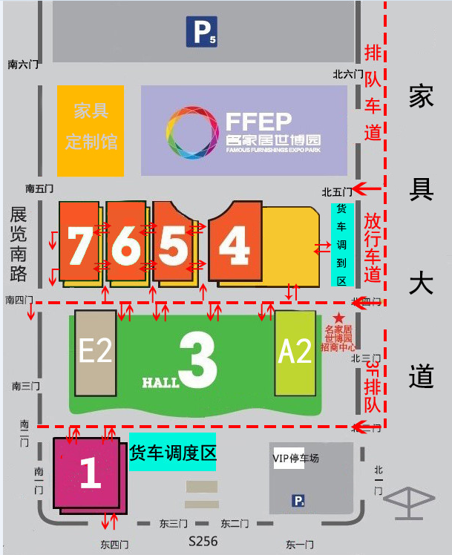
Truck Waiting Area
South Gate 1
South Gate 2
South Gate 3
South Gate 4
Exhibition Road South
South Gate 6
South Gate 5
Lining up Lane
Furniture Road
North Gate 3
North Gate 1
East Gate 4
East Gate 1
East Gate 2
East Gate 3
VIP Parking Lot
North Gate 2
FFEP Investment Promotion Center
North Gate 4
Release Lane
North Gate 6
North Gate 5

A2. Transportation Guide
Transportation Service for 2017 Maritime Silk Road Expo

1. Airport Pickup Service
Date | Route | Business Vehicle Service | Minibus Service
Sept. 20-22 | Guangzhou Airport → Hotels in Houjie | 10:00-22:00  Departs Guangzhou Airport every 30 minutes  Departs Shenzhen Airport every hour | 13:00-18:00  Departs every hour
 | Guangzhou Airport → Hotels in Nancheng, Wanjiang and Liaobu
 | Guangzhou Airport → Hotels in Humen
 | Shenzhen Airport → Hotels in Houjie
 | Shenzhen Airport → Hotels in Nancheng, Wanjiang and Liaobu
 | Shenzhen Airport → Hotels in Humen
If you are at Guangzhou Baiyun International Airport, please call 13929206013.
If you are at Shenzhen Bao’an International Airport, please call 13902696200.

2. Airport Drop-off Service
Date | Route | Coach Service
Sept. 23-25 | Exhibition venue → Guangzhou Airport | 14:00-19:00  Departs every hour with a total of six shifts per day
 | Exhibition venue → Shenzhen Airport
For this service, please call 18038388111.

3. Shuttle Bus Service between Humen Railway Station and the Exhibition Venue
Route  Route | Time | Shift
Humen Railway Station - Exhibition Venue | 10:00-19:00, Sept. 20-25 | Every hour
Exhibition Venue - Humen Railway Station
Guangzhou South Railway Station - Exhibition Venue
Exhibition Venue - Guangzhou South Railway Station

If you are at Humen Railway Station, please call 13929205203.
If you are at Guangzhou South Railway Station, please call 13929208836.
Region | Route | Pickup Spot | Departure Time | Shift
Nancheng | A | Dongguan Exhibition International Hotel  Leisure Hotel, Dongguan  Guangdong Modern International Exhibition Center | Sept. 21(7:30-18:00)  Sept. 22-24 (8:00-18:00) | Every 30 minutes
 | B | New City International Hotel, Dongguan  Victory Hotel, Dongguan  Guangdong Modern International Exhibition Center | Sept. 21 (7:30-18:00)  Sept. 22-24 (8:00-18:00) | Every 30 minutes
 | C | Hengxin Hotel  Silver World Garden Hotel  Hotel Silverland - Dongguan  Guangdong Modern International Exhibition Center | Sept. 21(7:30-18:00)  Sept. 22-24 (8:00-18:00) | Every 30 minutes
 | D | Nile Villa International Hotel  Winnerway Hotel  Guangdong Modern International Exhibition Center | Sept. 21(7:30-18:00)  Sept. 22-24 (8:00-18:00) | Every 30 minutes
Houjie | E | Sheraton Dongguan Hotel  Haiyatt Garden Hotel Houjie  Guangdong Modern International Exhibition Center | Sept. 21(7:30-18:00)  Sept. 22-24 (8:00-18:00) | Every 30 minutes
 | F | Grand Mercure Dongguan  HJ International Hotel  Guangdong Modern International Exhibition Center | Sept. 21(7:30-18:00)  Sept. 22-24 (8:00-18:00) | Every 30 minutes
 | G | JOYC Hotel  Dongguan Junhao Hotel  Vienna Hotel (Jinzuo)  Guangdong Modern International Exhibition Center | Sept. 21(7:30-18:00)  Sept. 22-24 (8:00-18:00) | Every 30 minutes
 | H | Sunshine Capital Hotel  Dongguan Chuangjiang Jingpin Hotel  DeRUCCI HOTEL, Dongguan  Guangdong Modern International Exhibition Center | Sept. 21(7:30-18:00)  Sept. 22-24 (8:00-18:00) | Every 30 minutes
 | I | La Quay Hotel  Guangdong Modern International Exhibition Center | Sept. 21(7:30-18:00)  Sept. 22-24 (8:00-18:00) | Every hour
Humen | J | Grand Noble - Dongguan  Grand Mercure Dongguan  Guangdong Modern International Exhibition Center | Sept. 21(7:30-18:00)  Sept. 22-24 (8:00-18:00) | Every 30 minutes
 | K | Loiyan Hotel, Dongguan  Forla Hotel, Dongguan  Guangdong Modern International Exhibition Center | Sept. 21(7:30-18:00)  Sept. 22-24 (8:00-18:00) | Every 30 minutes
 | L | Richwood Garden Hotel, Humen  Lung Chuen International Hotel  Guangdong Modern International Exhibition Center | Sept. 21(7:30-18:00)  Sept. 22-24 (8:00-18:00) | Every 30 minutes
Liaobu | M | South America Holiday Hotel, Liaobu, Dongguan  Guangdong Modern International Exhibition Center | Sept. 21(7:30-18:00)  Sept. 22-24 (8:00-18:00) | Two shifts respectively in the morning and in the evening
4. Shuttle Bus Service between Designated Hotels and the Exhibition Venue
Remarks:
1. Shuttle bus service for Sept. 20 (the day of move-in) will be arranged based on actual occupancy of exhibitors;
2. Shuttle bus service between hotels shall be subject to actual arrangement.

Transportation Reference Information
High-speed Rail
Northbound: Futian Station (Shenzhen Metro) → (Longhua Line of Metro) Shenzhen North Railway Station → (High-speed Rail) Shenzhen North Railway Station →Humen Railway Station
Shenzhen North Railway Station in the Metro system is connected to Shenzhen North Railway Station in the High-speed Rail system. It only takes walking distance to buy high-speed rail ticket at the ticket office downstairs after exiting from the subway station. It takes 17 minutes and costs RMB 40 on the train from Shenzhen North Railway Station to Humen Railway Station. The train runs in every half an hour.

Southbound: Guangzhou South Railway Station → Humen
It takes 17 minutes and costs RMB 35 on the train from Guangzhou South Railway Station to Humen Railway Station. The train runs in every half an hour.
Exit Humen Railway Station and then take a taxi (about RMB 20 and a 10-minute ride) directly to the destination, or take Line 2 of Dongguan Rail Transit to the Exhibition Center Station, or take any of the following buses: Bus 67/107/118/118a/213/310/L1/219.

Shuttle Buses
Guangzhou Baiyun International Airport GD Modern International Exhibition Center
1 Airport Express Line 1 Civil Aviation Ticket Office (Next to the Railway Station)
7:00---End of Service departs every 20 minutes RMB 16.00
Guangzhou Bus Station (Opposite to the Railway station) Shatian Town (Stop by GD Modern International Exhibition Center)
6:30-20:30 departs every 30 minutes RMB 40.00

2 Airport Express Line 1 Civil Aviation Ticket Office (Next to the Railway Station)
7:00---End of Service departs every 20 minutes RMB 16.00
Guangzhou Bus Station (Opposite to the Railway station) Houjie Special Line Station
6:30---20:30 departs every 30 minutes RMB 35.00
Taxi GD Modern International Exhibition Center
It takes about 15 minutes and costs RMB 20 to the destination.

3 Airport Express Line 8 Guangyuan Coach Terminal
7:10---22:30 departs every 30 minutes RMB 15.00
Guangyuan Coach Terminal Houjie Special Line Station
7:00---20:00 departs every 40 minutes RMB 35.00
Taxi GD Modern International Exhibition Center
It takes about 15 minutes and costs RMB 20 to the destination.

Shenzhen Bao'an International Airport GD Modern International Exhibition Center
Shuttle bus of the Airport: Shekou Dongguan (Coach Terminal)
7:30-20:30 departs every hour RMB 50.00
Dongguan (Coach Terminal) Humen (Stop by GD Modern International Exhibition Center)
6:30-18:30 departs every 10 minutes RMB 6.00

Guests from different places may choose the following means to go to Houjie Town.
Guangzhou, Dongguan, Shenzhen railway stations GD Modern International Exhibition Center
1. Guangzhou Bus Station (opposite to the Railway Station) Shatian Town (Stop by GD Modern International Exhibition Center)
6:30-20:00 departs every 30 minutes RMB 40.00
Guangzhou Bus Station (Opposite to the Railway station) Houjie Special Line Station
6:30-20:30 departs every 30 minutes RMB 35.00
Taxi GD Modern International Exhibition Center
It takes about 15 minutes and costs RMB 20.00 to the destination.
Guangdong Coach Terminal (next to the Railway Station) Houjie Coach Terminal
6:30-20:30 departs every 30 minutes RMB 38.00

2. Dongguan Railway Station (Changping) GD Modern International Exhibition Center
Bus 92 Houjie Coach Terminal
6:10-18:00 departs every 30 minutes RMB 20.00
Taxi GD Modern International Exhibition Center
It takes about 10 minutes and costs RMB 20.00 to the destination.

3. Shenzhen Railway Station GD Modern International Exhibition Center
Luohu Commercial City Bus Station Houjie Special Line Station
7:35-21:05 departs every 30 minutes RMB 45.00
Taxi GD Modern International Exhibition Center
It takes about 15 minutes and costs RMB 20.00 to the destination.

For bus line and schedule service, please call:
0769-85829838，85829778

Layout of GD Modern International Exhibition Center

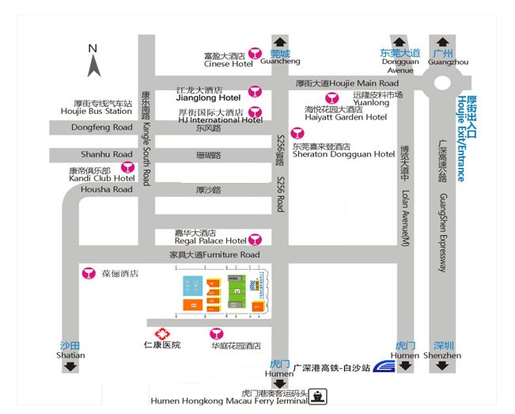

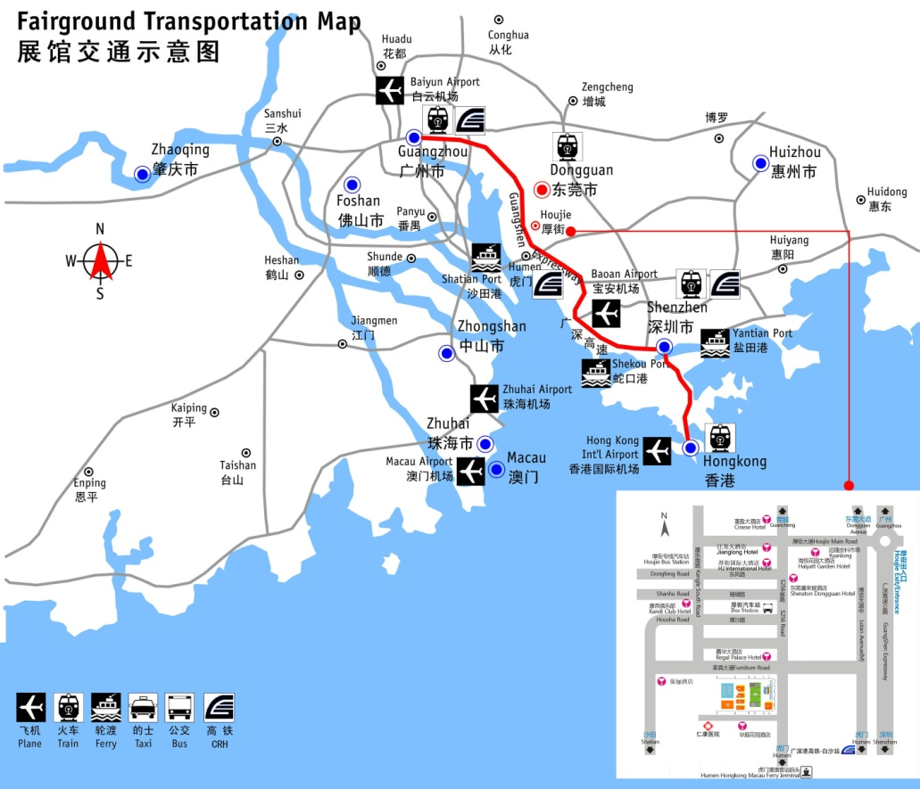

Chapter III Instructions to Exhibitors
B1. List of Forms for Exhibitors
To facilitate exhibitors to well prepare themselves for the exhibition and clearly understand the registration information and the services available, exhibitors shall fill out the following forms and submit them before corresponding deadlines; otherwise, any and all consequences or expenses incurred due to delayed submission shall be solely borne by exhibitors themselves.
Page | Form | Standard Stand Exhibitor | Raw Space Exhibitor | Deadline
P18 | C3 Layout of Exhibition Stands | Not required | Required | Sept. 5
P19 | C4 Application Form for Exhibition Equipment Lease | To be filled out and submitted as needed. |  | Sept. 5
P23 | C7 Construction and Decoration Contractor Application Form | Not required | Required | Sept. 5
P24 | C8 Application for Lighting | To be filled out and submitted as needed. | Required | Sept. 18
P25 | C9 Lighting Application Plan |  |  | Sept. 18

B2. Instructions to Exhibitors
1.Exhibitors shall comply with relevant national laws and regulations on intellectual property protection; otherwise, they shall bear all the consequences themselves. For exhibits involving trademark, patent or copyright, exhibitors must obtain relevant legal patent certificate or license contract.
2.Please carry the Exhibitor Badge (One Badge for each person) with you all the time and do not transfer it to others. Please show your cooperation to present your ID while entering into the Exhibition Hall. Children under 12 years old will be denied entry into the exhibition hall on Sept. 21 and 22 when it is open only to professional buyers.
3.During the Expo, exhibitors may enter into the exhibition areas half an hour ahead of the visitors to organize their stands. Please refer to “Expo Schedule” hereof for more information.
4.Exhibitors must complete organization of their stands and arrangement of their exhibits before 6 p.m. on Sept. 20 when the whole Exhibition Hall will be closed. Unless otherwise specially approved, access to the Exhibition Hall is prohibited.
5.Exhibitors must ensure the proper behaviors of their staff. Unless otherwise invited, exhibitors and their employees shall not enter into other stands without permission.
6.Public security service is available during the Expo to ensure the safety of both the Exhibition Hall and the exhibits to the best. However, we will assume no financial or legal liability for any risk arising out of the exhibits and personal belongings. Should you have any question about the security, please call 0769-85981505.
7.Please take security measures against thefts during the exhibition and remind visitors to your stand of the custody of their money, video recorder, camera, portable computer, mobile phones and other precious articles. In case of stolen article or suspicious situation, please go to the Security Office in the Exhibition Center or turn to the security personnel on the spot for help.
8.The first two days of the Expo are for professional purchase, while the last day is public open day.
9.No field sale is arranged during the professional purchase days (Sept. 21 and 22). All departing cargoes (samples) are not allowed to leave the Exhibition Hall until a Release Pass has been issued by the exhibitor and approved by the Expo. Entry of cargoes to the Exhibition Hall is also forbidden. Exhibitors shall not store their commodities of large quantity in the stands. If necessary, they can store such items in the temporary warehouse provided by the Expo.
10.Field sale will be allowed on Sept. 23 and 24 when the exhibition is open to the public. Exhibitors having new cargoes enter into the exhibition hall must make a prior application with the Service Center for a Cargo-in Slip by presenting its Booth Confirmation Letter. Such cargos shall enter through the designated entrance before 10am on the public open days. Exhibitors are required to complete relevant preparatory work, such as:
A.The quoted prices are recommended to be set as integers for convenience in dealing with the changes on site.
B.Ensure sufficient stock for sale and organize warehousing and replenishment properly. In case of assistance wanted, please contact the freight forwarders designated by the Expo.
C.Field sales is settled in cash, so please be well prepared.
D.Field sales may involve invoicing, so please be well prepared. In case of assistance wanted, please contact the One-stop Service Center.
E.If stands need decorating to cater to field sales, please prepare display stands, racks and fitting rooms by yourselves. In case of assistance wanted, please contact the designated contractor in advance.
11.Moving out ahead of schedule is not permitted. Exhibition stands must be under continuous supervision during the exhibition. Transfer of the stand, either wholly or in part, is not permitted.
12.Exhibitors can only carry out business or advertisement activities within their own stands. They are not allowed to hand out any product category, brochure, souvenir or other similar articles out of their stands.
13.To create a pleasant exhibition environment, exhibitors are required to keep the volume under 65 db when playing audio equipment or carrying out promotional performance within their stands; otherwise, both the Expo and owner of the exhibition halls may take such measures as disconnecting power supply to the stand.
14.Nail pounding, hole picking, posting or scrawling on the walls, columns, doors, windows, floors or display boards in the exhibition halls are prohibited. If the structure or facilities of the Exhibition Center are damaged, liability for damage will be investigated against the responsible person.
15.Sanitation of the public places and passages will be maintained by the Expo, while rubbish within the stands shall be cleared by exhibitors themselves. Exhibitors must move all abandoned materials from their stands to the designated places in time. If there is any packing or decoration material left in the stand, our cleaning staff will clear up, but the deposit already paid for hygiene maintenance will not be returned.
16.To maintain good hygiene conditions in the exhibition area, please have your meals in the designated dining area and use catering providers approved by the Expo. Both the Expo and owner of the exhibition halls shall have the right to confiscate or deny entry into the exhibition area of any food provided by a non-approved catering provider. Eating or excessive drinking in the stand is not permitted. Unwanted materials shall be put in the dustbins or on the passage during site-clearing.
17.Exhibition Hall Hygiene Maintenance Service Call: 0769-85981995.

B3. Regulations on Fire Safety
All exhibitors, contractors and staff shall comply with the Fire Control Law of the People’s Republic of China and the regulations on fire safety made by GD Modern International Exhibition Center.
1.Smoking is strictly prohibited within the Exhibition Hall. Violators will be answered with serious punishment depending on the circumstances.
2.Passages shall be kept cleared. The width of the main passages shall not be less than 3 meters. Evacuation exits shall be kept cleared and unlocked. It is prohibited to place exhibits or relevant materials in the passages, stairs or elevators, and violators will be ordered to remove such articles.
3.It is prohibited to connect electric wires or install electrical equipment (including illuminating lamps and advertising lamps) without permission. If it is necessary to install such equipment, exhibitors shall make application to the nominated contractor and acquire approval in advance. Electricians must be holders of relevant certificates. Construction and decoration materials must be qualified products; otherwise any accident or dispute caused by the use of sub-quality products will be solely borne by exhibitors themselves. During installation, fire retardant electric wires shall be used and regulations on electricity safety shall be abided by. Power supply will not be available, unless relevant approval is given after inspection.
4.If exhibitors need to construct or decorate their stands, display stands (racks), bill boards or scaffoldings by themselves, they shall make application to the nominated contractor in advance and cannot start construction or decoration without approval. Materials used in construction or decoration must be fire retardant or incombustible; otherwise, violators shall be ordered to dismantle them.
5.Fire fighting facilities, for example fire hydrants, shall be free from blockage, appropriation, occupation or damage during construction, decoration or arrangement of the stands. The top of the construction frame and the stand shall not be covered in any form to avoid malfunction of the fire sprinklers and smoke detectors.
6.Heating appliances and high-power lamps, such as electric stoves, kettles, irons and tungsten lamps, shall not be used in the Exhibition Hall. Neon lamps are prohibited, either.
7.Poisonous or dangerous articles, including fireworks, firecrackers, petroleum, thinner, alcohol, gas, hydrogen, oxygen or dangerous and toxic chemical products, cannot be brought into the Exhibition Hall. If exhibits fall into such category, substitutes thereof shall be used. If any of such articles is necessary for construction or performance, exhibitors shall apply to the nominated contractor in advance for approval and appoint professionals to supervise the use of such articles for safety purpose.
8.Packing cases, sundries, paper scraps and unnecessary exhibition samples must be removed out of the stands and shall not be left within the stand, on the racks or wooden partitions; or violators shall be ordered to clear them and subject to punishment.
9.Please keep the stand cleared after exhibition and ensure its safety. Heads up: (1) remove all combustible sundries, kindling and other potential hazards; (2) Cut the power off.
10.If working with naked fire (such as electric welding and gas welding) is necessary during construction or performance, exhibitors shall make application to the Organizing Committee of the Expo in advance and shall not start construction or performance without approval.

Chapter III Exhibition Stands
C1. Basic Facilities of and Regulations on Standard Stands
1.Each standard stand will be equipped with the following basic facilities:
Doorplate of company (on the lintel of the stand): exhibitor’s Chinese name and stand number;
Wall planks of the stand: A standard stand will consist of an aluminum frame, a signboard and three plank walls with a height of 2.5 meters;
Furniture: an information desk, a negotiation table, two collapsible chairs, a waste paper basket and a carpet;
A 500 w single-phase socket (only applicable to small electrical appliances instead of lamps or machines); two spotlights for the signboard;
Please refer to the facilities for stands of different areas in the following table. All supporting facilities (including furniture and electrical appliances) in the standard stands cannot be changed.
Item | ≤9㎡ | 18㎡ | 27㎡ | 36㎡
Information desk | 1 | 1 | 2 | 2
Negotiation table | 1 | 1 | 2 | 2
Collapsible chair | 2 | 2 | 6 | 6
Waste paper basket | 1 | 1 | 2 | 2
500 w single-phase socket | 1 | 2 | 2 | 4
Spotlight or 40 w fluorescent lamp | 2 | 4 | 6 | 8

2.If the exhibitor has two or more contiguous stands, except specially required by the exhibitor, the wall planks between the stands will be removed.
3.Exhibitors shall, before Sept. 5, submit the Layout of Stand, expressly indicating the construction or demolition situation of the wall planks and the exact position of the fluorescent lamps. In case of delayed submission, the stand will be arranged and organized by the Expo; however, if exhibitors need to re-arrange the stand, they shall pay for the decoration or reconstruction.
4.Nailing, drilling, spraying on or sawing off the wall planks is prohibited.
5.Devices that may influence the structure of the stand shall not be installed.
6.Paint or wall paper cannot be applied to the wall planks. Exhibitors may use the double-coating tapes but need to remove the stickers left on the plank walls after the closure of the Expo.
7.Exhibitors cannot move the leased exhibition appliances in their stands or other stands without approval; otherwise, violators shall be fined at the lease price of such appliances.
8.If special decoration, additional furniture or electrical appliances are needed in the stands, exhibitors shall make extra payment after filling out relevant application form.
9.Exhibitors of special stands shall fill out the Layout of Facilities in Standard Stands (which must be submitted) and the Application Form for Exhibition Equipment Lease (if necessary) and shall submit them to the Exhibition Affairs Office in time.

C2. Sketch of a Standard Stand (3M×3M)
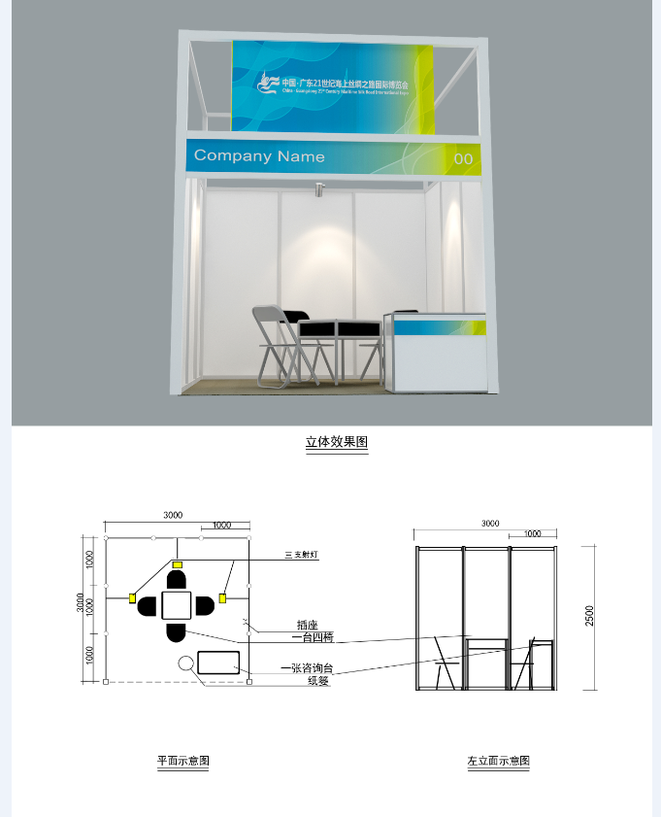
Plan sketch
Left vertical face sketch
Waste paper basket
1 info. desk
1 table & 4 chairs
Three-dimensional effect picture
3 spotlights
Socket

C3. Layout of Exhibition Stands (for Standard Stands)
Plan
0.5m

Illustration:
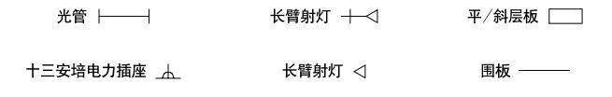
Light pipe Long-arm spotlight Level/sloping plate
13 ampere socket Long-arm spotlight Wall plank

Company Name:

Stand No.: Contact Person: Mr./Ms.

Tel.: Fax:

Company seal and signature:

Deadline: Sept. 5, 2017 Service Call: Ms. Huang 020-89268200, 89268266 Fax: 020-89268286
Email: huangxiaoying@cantonfairad.com
C4. Lease of Exhibition Equipment
Serial No. | Name | Specification (M) | Unit | Unit Price of Lease (Yuan) | Quantity | Total (Yuan)
1 | Collapsible chair | White | Piece | 50
2 | Information desk | 1×0.5×0.75 | Piece | 120
3 | Negotiation table | 0.65×0.65×0.75 | Piece | 120
4 | Glass round table | Diameter 0.9 | Piece | 180
5 | Supporting plate | Straight plate 1M×0.3 | Piece | 60
 |  | Sloping plate 1M×0.3 | Piece | 70
6 | Carpet | All kinds of colors | ㎡ | 30
7 | Short showcase (without lights) | 1×0.5×1 | Set | 300
8 | Short showcase (with one 40 w fluorescent lamp) | 1×0.5×1 | Set | 400
9 | Folding door | 1*2.5 (with lock; 50 yuan deposit) |  | 400
10 | Square table | 0.65×0.65×0.65 Deposit：150 yuan |  | 120
11 | Arc information desk | 1MH |  | 350
12 | Isolation belt | 1M | Piece | 50
13 | Spotlight | 100W | Piece | 90
14 | Quartz lamp | 35W | Piece | 80
15 | Fluorescent lamp | 40W | Piece | 80
16 | Fluorescent lamp within the showcase | L0.9M, 40W | Piece | 80
17 | Quartz lamp within the showcase | Standing lamp 35W | Piece | 100
18 | Sunlamp | 100W | Piece | 150
 |  | 300W | Piece | 250
 |  | 500W | Piece | 320
19 | Halogen lamp | 70W | Piece | 300
 |  | 250W | Piece | 400
 |  | 500W | Piece | 400
Total

Notes:

1.If exhibitors desire to lease any article not listed above, they may make a call to the Exhibition Affairs Office for relevant information.
2.Application shall be made for the lease in advance. In case of on-site leasing, the applicant shall be charged an extra cost of 10%. The leased articles will be sent to the according stands before the opening of the Expo.
3.Please make payment for the lease in cash on the spot.
4.The above-mentioned exhibition equipment or exhibits are for lease only. During the lease, exhibitors shall take good care of such leased items. If case of damage or loss, the exhibitor concerned shall compensate at 3 times of the lease price of the item or compensate with the paid deposit.

Company Name:

Stand No.: Contact Person: Mr./Ms.

Tel.: Fax:

Company seal and signature:

Deadline: Sept. 5, 2017 Service Call: Ms. Huang 020-89268200, 89268266 Fax: 020-89268286
Email: huangxiaoying@cantonfairad.com
C5. Samples of Exhibition Equipment
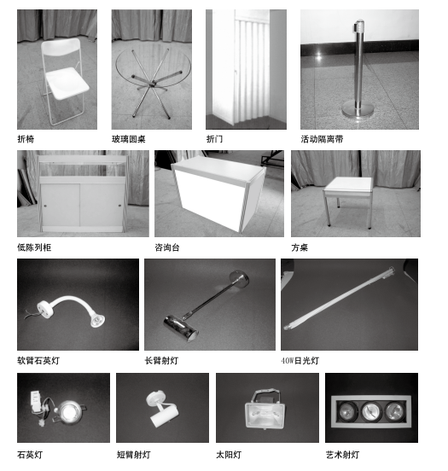
Collapsible chair Glass round table Folding door Isolation belt
Short showcase Information desk Square table Soft-arm quartz lamp
Long-arm spotlight 40 w fluorescent lamp Quartz lamp
Short-arm spotlight Sunlamp Artistic lamp

C6. Instructions on Special Stand Construction
In order to maintain internal and external construction order of the Exhibition Center and ensure safety during construction, both the exhibitors and the construction units shall comply with the following regulations:
(1)Certificate application procedures for construction units
Provide the required certificates and drawings
Return them before June 5
Fill out the Application Form of Special Stand Decoration and return it before Sept. 5

Collect the construction certificates and start construction in the Exhibition Center

Pay deposit for the land of special stand construction in the Customer Service Office of Exhibition Center with the presence of Application Form of Contractor for Special Stand Construction

Note: Please provide the following documents to the Exhibition Center before starting construction and go through relevant formalities.
A. One copy of business license.
B. Plan, design sketch and circuit diagram of the construction
C. List of the construction personnel and their types of work, ID numbers and the contact information of the on-site responsible person
- Designers, electricians and other personnel of special type of work shall provide the copies of relevant technical certificates issued by the national authorities.
We are only responsible for examining and approving the structure instead of the height limit of special positions and other special issues.

Please fax/email above documents before Sept. 5 to:
GD Modern International Exhibition Center
Tel: 0769-85981860 /85981881 Fax: 0769-85981788
Email: gdmsr21@126.com

(2) In case of construction of special stands, following expenses shall be paid to the Construction Management Office:
A. Deposit: 5000 yuan/exhibitor/exhibition period
B. Electric charges for lighting in the special stands (please refer to Application for Lighting below for more information)
(3) Constructors of special stands shall comply with the following regulations:
A. Fire retardant materials shall be used in construction to ensure firm structure and safety of the stand.
B. Combustibles or explosives are prohibited in the construction site. It is also forbidden to smoke or work with naked fire on the site.
C. The stand structure shall not be attached to or hung on the grid structure of the Exhibition Hall.
D. Exits near the fire hydrants and electric cabinets shall be cleared.
E. In the case that the height of stand is over 2.5 meters, the side of wall facing to the conjoint stand shall be clean and white, so that the exhibitor of such conjoint stand can use this side of wall for promotion activities.
F. All construction materials shall be placed within the stands and the passages shall be kept cleared. During Move-out, contractors of special stands shall clean up the site and can only get their paid deposits back by presenting the deposit receipt after being checked and approved by the Exhibition Center.
G. Electronic ballasts instead of magnetic ones shall be applied in the fluorescent lamps.
H. Sufficient ventilation holes for heat emission shall be available in the light boxes. The ballasts of the fluorescent lamps shall be separated from the light boxes. Fire fighting measures shall be taken in the case that the light boxes are made of combustible materials.
I. Double insulation sheathed lines shall be applied in installation of electrical appliances. Binding posts shall be used in the connecting points. Installation of electrical appliances shall accord with relevant regulations. The operation shall be standardized to ensure both power supply safety and electricity safety.
J. Electrical materials and lamps installed in the stands shall be examined and approved by relevant industrial departments. Certificates of Quality for these materials and lamps are required.
K. During the construction of stand or platform, punching, painting, sizing, posting or tinting on the walls or floors are prohibited. All facilities within the Exhibition Hall shall be maintained well.
L. The constructed stand shall not block the fire fighting apparatuses, electrical equipment, emergence exits or the passages for visitors within the Exhibition Hall. Display racks or stands shall not be constructed near the fire resisting shutters.
M. If exhibitors need to hang banners (or solid objects) on the grid structure, they shall make application to the Office of Technical Support and Construction Management and acquire approval before they start construction.
N. The construction unit shall make a true declaration about the construction area, number of the construction personnel as well as the water, electricity and gas supply situation. The actual construction area shall be in strict accordance with the declared area and any holder of relevant certificates shall not transfer the use thereof to others.
O. The construction unit must appoint an on-site responsible person to supervise the construction site and information about such responsible person shall be filed while the construction formalities are being handled. The on-site responsible person shall enter into a Safety Responsibility Agreement with the Office of Construction Management.
P. If any accident happens during construction, the construction unit shall contact the Office of Construction Management in time.
Q. The construction unit shall provide training opportunities to the construction personnel to raise their awareness about civilized construction and legal consciousness.

C7. Construction and Decoration Contractor Application Form
To facilitate the unified management and safety measures of stand construction in the Expo, exhibitors who appoint special decoration companies shall fill out the following application form:

Name of Constructor |  | Stand No. |  | Area: ㎡
Address |  | Phone
Email |  | Fax
Project Leader |  | Mobile
Main Contact Person |  | Mobile
Number of Certificates Required |  | Date of Application
Signature and seal of the responsible person:

Name of Exhibitor:

Stand No.: Contact Person: Mr./Ms.

Tel.: Fax:

Company seal and signature:
Email: gdmsr21@126.com
Deadline: Sept. 5, 2017 Service Call: 0769-85981860, 85981881 Fax: 0769-85981788
Email: gdmsr21@126.com

C8. Application for Lighting
Lighting is only available for the public areas and the standard stands. Exhibitors of raw space and special stands shall apply for power supply for lighting. Items and prices are listed below:
Item | RMB(yuan) | Quantity | Amount
Square-feet socket 13 ampere single-phased power supply (not over 1500 w) | 300
Square-feet socket 15 ampere single-phased power supply (not over 2000 w) | 500
Lighting source (indoor) 220V/15A | 650
Lighting source (indoor) 220V/20A | 700
Lighting source (indoor) 220V/30A | 1100
10 ampere three-phased power supply | 700
15 ampere three-phased power supply | 800
20 ampere three-phased power supply | 900
25 ampere three-phased power supply | 950
30 ampere three-phased power supply | 1300
40 ampere three-phased power supply | 2200
50 ampere three-phased power supply | 2500
60 ampere three-phased power supply | 3300
Temporary power supply for construction 10A/220V (only available during exhibition arrangement) | 300
Temporary power supply for construction 13A/220V (only available during exhibition arrangement) | 350

Total:
Notes:
1.The prices listed above are the electric charges during exhibition, including electricity box connecting, material, construction expenses and taxes.. Such services are only for rent.
2.Please make application before Sept. 18; otherwise, an extra cost of 20% will be charged. The Engineering Dept. of the Exhibition Center may refuse, or accept by charging an additional cost of 30%, any application made on or after Sept. 23.
3.Cancellation of application must be made in writing. Cancellation made after the specified deadline will cost a 20 % cancellation fee. No cancellation can be made after Sept. 23.
4.Upon receipt of the application forms from the exhibitors, the Exhibition Center will fax them a Confirmation Letter, with the presence of which exhibitors can check and accept the applied project on the spot.
5.Consulting Service Call: 0769-85981860 / 85981881

Application will not be confirmed until the Exhibition Affairs Office of Secretariat has examined and approved such application and relevant payment has been made.

Company Name:

Stand No.: Contact Person: Mr./Ms.

Tel.: Fax:

Company seal and signature:

Deadline: Sept. 18, 2017 Service Call: 0769-85981860, 85981881 Fax：0769-85981788
Email: gdmsr21@126.com

C9. Lighting Application Plan
Please mark the positions of the applied lighting items (including basic and additional facilities) in the following rectangle which represents the corresponding stand, and fill in the ( ) with the numbers of the stands next to such stand to identify its direction. Should any exhibitor fail to submit such plan, the Exhibition Affairs Office will install the lighting equipment in appropriate positions, and any change to such positions by the exhibitor will result in additional charge.
Plan
Number of the Stand Above: ( )

下

Number of the Stand Below: ( )
Illustration
Lighting electricity box Broadband

Name of Exhibitor:

Stand No.: Contact Person: Mr./Ms.

Tel.: Fax:
Company seal and signature:

Deadline: Sept. 18, 2017 Service Call: 0769-85981860, 85981881 Fax: 0769-85981788
Email: gdmsr21@126.com

C10. EXTRA HOUR CHARGE

DURATION OF EXTRA HOUR | PRICE (RMB)
Before 00:00(MINIMAL 3HOUR) | 12/㎡/3hour | Minimal 100㎡(net area); area larger than 100㎡shall be subject to the actual area.
After 00:00(MINIMAL 1HOUR) | 8/㎡/hour

Remarks:
1.Extra hours required will be subject to the approval of the Exhibition Center and payment of the above charge as applicable.
2.Extra hours APPLICATION FORM should be hand in before 16:00pm to the Customer Service Center, otherwise 100% of the extra hour charge will be added, or the Customer Service Center could refuse the application.
3.Fees of general lighting and public security are included in the above charges.
4.If the move-in date is moved up, the rental is subject to the Exhibition Center’s Hiring Rate.
5.The extra hour charge should be paid according to the actually used area (e.g. 12yuan/㎡/3hour×100㎡).
6.If the move-out date is postponed, 400% of the rental will be added(the extra area is subject to area of a single section).

Chapter V Business Reception
There are almost 100 nearby hotels of different scales from where it only takes about 20 minutes’ driving to the Exhibition Center, and a dozen of them are 3-star or higher-level hotels, providing 3,000 guest rooms. It only takes 30 minutes to drive to Dongguan, Humen and Chang’an where additional 10,000 guest rooms are available.

Please contact China Comfort Travel (Dongguan) for room reservation service:
Contact Person: Ms. Chen Jingna Tel: 0769-22000993 or 13929205203 Fax: 0769-22000977

Information of Selected 3-star or Higher-level Hotels in Dongguan
Hotel Name | Star Level | Address | Telephone | Hotel Name | Star Level | Address | Telephone
Regal Palace Hotel Dongguan | 5-star | No. 1, Furniture Road, Houjie Town | 0769-85928888 | Leisure Hotel, Dongguan | Business hotel | No. 7, Tiyu Rd., Nancheng District | 0769-22995678
Dongguan Well Garden Hotel | 4-star | South of GD Modern International Exhibition Center, Houjie Town | 0769-81633333 | Winnerway Hotel Dongguan | Business hotel | No. 1, Hongyuan Road, Nancheng District | 0769-22418888
Sheraton Dongguan Hotel | 5-star | Guantai Road section of S256 Provincial Road, Houjie Town (opposite the township government) | 0769-85988888 | New City International Hotel, Dongguan | Business hotel | Junction of Guantai Rd. and Hongfu Rd. (near Dongguan International Convention and Exhibition Center) | 0769-38832222
Boshi Business Hotel - Dongguan | Business hotel | No. 88, Fenghuang Road, Xin Tang, Houjie Town | 0769-85083888 | 东莞恒新时尚精品酒店 | Business hotel | 南城区银丰路18号，近南城医院 | 0769-22881618
DeRUCCI HOTEL, Dongguan | High-end business hotel | Zemei section of Kangle S. Road, Houjie Town | 0769-82908888 | Silver World Garden Hotel | Business hotel | Junction of Yinfeng Rd. and Guantai Rd, Nancheng District (near Yinfeng Business Building) | 0769-22803888
Cinese Hotel Houjie - Dongguan | 5-star | Junction of Dongguan Exit (of Guangzhou-Shenzhen Expressway) and Dongguan Avenue, Houjie Town | 0769-85888888 | Hotel Silverland - Dongguan | High-end business hotel | No. 48, Guantai Road, Nancheng District | 0769-2282888
La Quay Hotel | Business hotel | No. 41 & 42, North of Huizhan E. Road, Furniture Avenue, Houjie Town | 0769-83088888 | Nile Villa International Hotel | Business hotel | MALL·生活城F3区  Living City F3, New South China Mall, No. 10, South of Wanjiang Rd., Wanjiang District | 0769-22706666
Haiyatt Garden Hotel, Houjie, Dongguan | High-end business hotel | No. 2-80, East of Houjie Avenue, Houjie Town | 0769-85885888 | South America Holiday Hotel, Liaobu, Dongguan | Business hotel | No. 36, Fuxing Rd., Chenjiapu Village, Liaobu Town | 0769-83278888
HJ International Hotel - Dongguan | 5-star | Junction of Dongfeng Rd and S256 Provincial Road, Houjie Town (near Houjie Int’ Commercial Plaza and Houjie Township People’s Government) | 0769-85088888 | Lung Chuen International Hotel | Business hotel | Jinzhou Section, Liansheng Road, Humen Town | 0769-85188688
JOYC Hotel | Business hotel | Junction of Xinhousha Avenue and Nanhuan Road, Houjie Town | 0769-82683333 | Grand Noble - Dongguan | Business hotel | No. 121, Humen Avenue, Humen Town (near Jinlong Rd.) | 0769-85117888
Junhao Hotel, Dongguan | Business hotel | Junction of Kangle S. Rd. and Nanhuan Rd. (near Houjie Bus Station) | 0769-89986688 | Forla Hotel, Dongguan | Business hotel | No. 193, Humen Avenue, Humen Town | 0769-85022222
Vienna Hotel, (Dongguan Houjie Jinzuo) (former Jinzuo Hotel) | Business hotel | No. 3, Kangle S. Rd., Houjie Town (Junction of Kangle S. Rd. and Housha Rd.) | 0769-85882828 | Loiyan Hotel, Dongguan | Business hotel | Bomei section of Renmin Rd., Humen Town | 0769-82263333
Exhibition International Hotel | 5-star | Huizhan N. Rd., New City Area, Nancheng District | 0769-22889999 | Richwood Garden Hotel, Humen | Business hotel | Dabandi section of S358 Provincial Rd., Humen Town | 0769-85708888
Victory Hotel, Dongguan | Business hotel | West side of Yuanmei Rd., Nancheng District (near Ya Tai Xin Cun) | 0769-22286888 | Grand Mercure Dongguan  (former Dongguan Huiyuan Huameida Hotel) | Business hotel | No. 123, Humen Avenue, Humen Town | 0769-85244888
Hotel Sunshine Capital | Business hotel | Shanhu Road intersection, S256 Provincial Road, Houjie Town | 0769-85881888 | Dongguan Chuangjiang Jingpin Hotel | Business hotel | Ci Bian Xiao Qu, No. 6, Housha Rd., Houjie Town | 0769-85998118

Chapter VI Translation Service
Dongguan Translation Service Center
Price List
Language | Translation |  | Liaison Interpretation
 | Chinese to Foreign Language  (Unit: 1,000 Chinese characters) | Foreign Language to Chinese  (Unit: 1,000 Chinese characters))
English | RMB 200 | RMB 150 | RMB 900
Japanese | RMB 200 | RMB 150 | RMB 900
Korean | RMB 200 | RMB 150 | RMB 900
French | RMB 450 | RMB 380 | RMB 2000
German | RMB 450 | RMB 380 | RMB 2000
Russian | RMB 450 | RMB 380 | RMB 2000
Spanish | RMB 550 | RMB 460 | RMB 2500
Italian | RMB 550 | RMB 460 | RMB 2500
Vietnamese | RMB 550 | RMB 460 | RMB 2500
Thai Language | RMB 550 | RMB 460 | RMB 2500
Portuguese | RMB 550 | RMB 460 | RMB 2000
Arabic Language | RMB 600 | RMB 550 | RMB 3000
Turkish | RMB 600 | RMB 550 | RMB 3000
Khmer Language | RMB 700 | RMB 600 | Negotiable
Malay Language | RMB 700 | RMB 600 | Negotiable
Indonesian | RMB 700 | RMB 650 | RMB 4000
Burmese | RMB 800 | RMB 700 | RMB 600/hour
Hindi | RMB 800 | RMB 700 | Negotiable
Hebrew Language | RMB 800 | RMB 700 | RMB 600/hour
Lao Language | RMB 800 | RMB 700 | Negotiable
Others | Negotiable

ADD.: 1/F, SCIENCE BUILDING, NO. 38 XINFEN ROAD, GUANCHENG, DONGGUAN, GUANGDONG, PRC, 523000
Tel: +86-769-22236445 22110768 23321686
Website: www.dgtsc.com

Chapter VII How to Obtain an Exhibitor/Purchaser/Visitor Pass
Procedure of Obtaining an Exhibitor/Purchaser/Visitor Pass

I. Exhibitors (Period of registration: Sept. 17-20)
(1) Exhibitor receives the Exhibitor Passes (enclosed in an envelope) on the spot by presenting the Booth Confirmation (sealed) and name cards of the participants. Exhibitor then signs on the Registration Form after checking the quantity of the Exhibitor Passes received.
(2) Exhibitor fills in an Application for Additional Exhibitor Passes if he or she wishes to apply for additional Exhibitor Passes. Additional Exhibitor Passes will be issued on the spot upon confirmation of the organizer.

Process of Obtaining an Exhibitor Pass

Exhibitor Pass
On-the-spot application
Prior application
Find the envelope and check the quantity of the Exhibitor Passes inside
Apply by presenting the Booth Confirmation (sealed) and the applicant’s name card
Check and sign to confirm
Fill in the Application for Additional Exhibitor Passes
Confirmation and signature by the organizer
Print additional Exhibitor Passes required

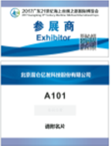

II. Professional Purchasers (including purchasers invited by relevant associations) (Days of professional purchase: Sept. 21-22)
(1) Pre-exhibition registration. If the registration is done via a PC, the purchaser brings his or her ID card and name card to a counter and has a Purchaser Pass printed by presenting relevant registration information. If the registration is done via WeChat, the purchaser shall have his or her Purchaser Pass printed at the automatic pass printer or at a counter after having his or her identify verified.
(2) Obtaining a Purchaser Pass on the spot: Domestic purchasers who have a name card can register via WeChat on the spot and have the Purchaser Pass printed at the automatic pass printer or at a counter (by showing relevant registration information) to the staff. He or she may also print the Purchaser Pass at a counter by presenting his or her name card and ID card, and then enter the exhibition hall through the facial recognition gate machine;
Domestic purchasers who do not have a name card need to fill out a Purchaser Registration Form and have their identities verified at a counter in the Registration Area. Then they can receive a Purchaser Pass and enter through the facial recognition gate machine;
Foreign purchasers who have a name card need to have their identities verified by producing a passport in order to receive a Purchaser Pass. Foreign purchasers who do not have a name card are required to fill out a Purchaser Registration Form and have their identities verified at a counter by producing a passport to the staff. Then they can receive a Purchaser Pass and enter through the facial recognition gate machine.

Process of Obtaining a Purchaser Pass
Pre-exhibition registration
On-the-spot registration
Fill in basic personal information to complete registration
Produce registration information and one name card
Identity verification
Have the Purchaser Pass printed at a counter
Via PC
Via Wechat
Upload the name card and fill in basic personal information to complete registration
Use ID card to have the Purchaser Pass printed at the automatic pass printer or a counter by showing the registration information
Have no name card
Have name card
Submit ID card and fill in Purchaser Registration Form
Obtain the Purchaser Pass at a counter
Identity verification
Have the Purchaser Pass printed at a counter
On-the-spot registration of foreign purchaser
Fill in the Purchase Registration Form and produce the passport
Produce one name card and the passport
On-the-spot Wechat registration
Submit ID card and one name card
Upload name card information and fill in basic personal information to complete the registration
Identity verification

Identity verification

Use ID card to have the Purchaser Pass printed at the automatic pass printer or a counter by showing the registration information
Purchaser
Have the Purchaser Pass printed at a counter
Have the Purchaser Pass printed at a counter
Enter through the facial recognition gate machine
III. General Public (Days of opening to the public: Sept. 23-24)
(1) Go to a counter at the Registration Area during the exhibition and have your identify verified by presenting your ID card or other identity document to the staff. Then receive a Visitor Pass;
(2) On-the-spot registration through WeChat: Fill in your basic personal information to complete the registration. Then show the registration information to the staff and enter through the facial recognition gate machine by producing your ID card.

Process of Obtaining a Visitor Pass
On-the-spot registration
Wechat registration
Visitors
Have your identity verified by presenting your ID card or other identity document to the counter staff
Fill in your basic personal information to complete the registration
Hold your ID card
Enter through the facial recognition gate machine
Receive a Visitor Pass

Chapter VIII Exit and Entry Clearance Guide for Exhibits
To facilitate the exit and entry clearance and quarantine and inspection for the travelling traders from different countries and to establish the order, on the basis of Administrative Measures of the Customs of the People’s Republic of China for Goods Temporarily Imported or Exported (Order of the General Administration of Customs No. 212, Law of the People's Republic of China on Import and Export Commodity Inspection, Law of people's Republic of China on the Entry and Exit Animal and Plant Quarantine, Law of People's Republic of China on Frontier Health and Quarantine and Law of the People's Republic of China on Food Hygiene, the Exit and Entry Clearance Guide for Exhibits of 2017 Guangdong 21st Century Maritime Silk Road International Expo (hereinafter referred to as “Clearance Guide”) is hereby enacted for reference to ensure that the exhibits could be admitted to the expo with safety, punctuality and success.
I. Clearance procedures and administrative regulations for entry of exhibits
(I) The imported exhibits (hereinafter referred to as “exhibits”) quoted in this Guide indicate the contents prescribed in the Fortieth Article in Administrative Measures of the Customs of the People’s Republic of China for Goods Temporarily Imported or Exported (Order of the General Administration of Customs No. 212) as follow:
1. Goods exhibited in the expo;
2. Goods used as model machines or appliances exhibited in the expo
3. Building and decoration materials for the temporary exhibition stands
4. Movies, slides, videos, audio tapes, specifications, advertisements, disks, display equipment or other materials used to promote and show the goods
5. Other goods exhibited in the expo.
(II) Unless otherwise prescribed by the national law, administrative laws and regulations, regulations by the General Administration of Customs or international treaties that our country concluded or entered into, when the exhibits are under entry clearance, it is not required to hand over the import license for examination. The imported exhibits shall be supervised by the Customs and Customs formalities shall be handled in accordance with the regulations by the Customs.
(III) Prohibited Inbound and Outbound Articles List of the People's Republic of China
1. Prohibited inbound articles
(1) All kinds of weapons, imitation weapons, ammunitions and explosives;
(2) Counterfeit currencies and negotiable securities;
(3) Printing materials, films, photos, records, movies, audio tapes, videotapes, laser discs, computer storage mediums or other articles that could do harm to the politics, economy, culture and moral codes in China;
(4) Deadly poisons of all kinds;
(5) Opium, morphine, heroin, marihuana or other addictive narcotic drugs and psychotropic drugs;
(6) Dangerous germs, pests or other harmful animals, plants and their derivative products;
(7) Food, medicines and other articles that do harm to the health of human beings and animals, come from epidemic areas or disseminate diseases;
2. Prohibited outbound articles
(1) Any article that is included in the list of the Prohibited Inbound Articles
(2) Drafts, printing materials, films, photos, records, movies, audio tapes, videotapes, laser discs, computer storage mediums or other articles whose contents involve the state secrets;
(3) Precious cultural relics and other prohibited outbound cultural relics;
(4) Endangered and rare animals and plants (including their specimens) and their seeds and breeding materials.
(IV) The local managing Customs of the exhibits indicate those located in the same region where the expo is held. For those inbound or outbound exhibits that undergo tran-Customs transportation, their local managing Customs shall be the designated destination Customs or the departure Customs of the tran-Customs transportation. The local managing Customs shall be responsible for the actual supervision over the goods temporarily imported or exported and shall take care of the relevant business related to the temporary entry and exit.
(V) The host unit of the Maritime Expo (hereinafter referred to as “Sponsor”) or its agent shall bring the following approval documents and relevant documents to go through the filing formalities in the local managing Customs 20 days before the entry of the exhibits.
1. Filing Registration Form for Exhibition (Made in duplicate);
2. Documents approved by the competent national authorities;
3. Relevant approval documents shall be provided in the case that some of the exhibits are restricted imported articles;
4. Overall scheme for the Expo;
5. Plan of the exhibition sections and List of the exhibitors;
6. List of the exhibits;
7. List of articles for the exhibition (articles to be expended and distributed during the Expo)
(VI) During the entry of the exhibits, the exhibitors or their agents shall bring the Filing Registration Form for Exhibition and list of exhibitions or other relevant documents to go through the declaration formalities for their exhibits in the local managing Customs. The exhibitors or their agents shall provide the local managing Customs with deposits as tax payment or other effective collaterals approved by the Customs. Such collaterals may be exempted with approval of the competent Customs authorities if the expo is to be held in a place designated by the Customs or supervised by special personnel designated by the Customs. The holder of the ATA Carnet shall provide the true and effective original ATA Carnet, correct list of goods and other relevant commercial documents or certificates. Guarantee for the exhibits described in the ATA Carnet will be provided by China Chamber of International Commerce for the General Administration of Customs.

Declaration procedures for entry of exhibits
Exhibitors provide the list of exhibits for their agents
Agents go through registration formalities for the exhibits in the Customs

Processing by the Customs
Exhibits transportation and entry; Declaration in the Customs

Payment of deposits and customs clearance procedure with the Customs

Transport the exhibits to the Expo for exhibition

(VII) Otherwise worn during the normal use, as articles temporarily imported, the exhibits shall be exported in their original state within 6 months after the entry date. If this term shall be prolonged due to some special situation, the sponsor and exhibitors shall bring the relevant approval documents issued by the original approval authorities to apply for such extension in the local managing Customs 30 days before the closure of the Expo.

Declaration procedures for the exit of exhibits
Export declaration for the exhibits
Customs examination and approval

Customs check and examination, clearance

Records cancellation after verification by Customs
Enterprises apply for deposits return from the Customs

Customs return the deposits after examination and approval and approve the clearance.

(VIII) The sponsor and exhibitors shall apply for the closure of the Expo in the filing Customs within 30 days after they have completed the formalities for their imported exhibits in the Customs.
(IX) As for the consumables or distributed goods (hereinafter referred to as articles for exhibition) in the Expo, the Customs will evaluate and confirm their quantity and total value on the basis of the nature of Expo and number of exhibitors and visitors. In addition, the Customs will also exempt the import tariff and import linkage tax to a reasonable extent according to relevant regulations:
1. Samples used in the Expo activities, including the samples of food or drinks that are imported with the original packaging or made of imported bulk raw materials during the Expo;
2. Materials consumed or damaged in the operation or demonstration of the exhibited machines or apparatuses;
3. Low value articles consumed during the decoration of the temporary exhibition stands;
4. Relevant advertisement articles distributed to the visitors free of charge during the Expo;
5. Records, forms or other documents used in the Expo.
The articles listed in the first item of the previous article shall meet the following requirements:
(1) The articles shall be provided by the exhibitors free of charge and exclusively distributed to the visitors for use or for consumption during the Expo;
(2) The articles are of relatively low price and exclusive for the use as advertisement samples;
(3) The articles are not for commercial use and their unit capacity shall be obviously smaller than the minimum retail packaging capacity;
(4) Though the samples of food and drinks are not distributed in the packaging as prescribed in the 3rd provision of this article, they have been actually consumed during the activities.
Regulations on tax exemption are not applicable to the alcoholic drinks, tobacco products and fuels for exhibition.
In the case that the articles for exhibition are under the management of relevant national licenses or certificates, such documents shall be provided for the Customs for examination and relevant entry formalities shall be handled.
If the quantity of the exhibits listed in the first item excels the limit, tax shall be paid by law for the excess part; the unused or unconsumed articles listed in the second, third or fourth item shall be exported back outbound, otherwise, relevant entry formalities shall be handled in accordance with relevant regulations.
(X) Records cancellation after verification by the Customs and Customs clearance
The imported exhibits declared by the Expo in the form of temporary entry are articles supervised by the Customs. After the Expo, the Customs clearance formalities shall be dealt with according to different transportation destinations of the exhibits.
1. Exhibits to be used for other exhibitions in China: where some of the exhibits need transporting to other exhibition venues after the Expo is closed, relevant tran-Customs transportation formalities shall be handled in accordance with the regulations on Customs transit.
2. Exhibits to be exported out of the country: The export formalities shall be handled with the competent Customs authorities by presenting the original entry declaration documents.
3. Exhibits to be imported formally: Application shall be made to the competent Customs authorities 30 days before the deadline for exit of exhibits, and with approval of the said Customs authorities, procedure for import of such exhibits can be handled.
(XI) On-site Supervision and Control by the Customs
Imported exhibits shall be stored in the supervision place designated by the Customs during the entire duration when they are not exhibited, and may not be moved out without approval of the Customs. If they need to be moved out due to special reasons, approval of the Customs must be obtained.
Before unpacking of the exhibits, the sponsor, exhibitor or his agent shall inform the Customs for examination and inspection. During examination and inspection by the Customs, the owner of the exhibits or his agent shall be on the scene to assist with the said inspection by performing such tasks as moving, opening, repacking and sealing, etc.

II. Inspection and quarantine method and procedures for the imported exhibits
(I) Inspection and quarantine procedures for the imported exhibits through the ports in Dongguan (please refer to the diagram below)

The sponsor or its agents shall apply for the filing for the exhibition 20 working days before its opening
Y
Examination and approval formalities for the exhibits required?

Y
Go through the examination and approval formalities according to relevant approval procedures

N
Declare to the inspection and quarantine authority in the port of entry

Quarantine performed at the port

Spot examination to the temporary supervisory or transit warehouses of the exhibition venue

Return or destroy the exhibits
Do the exhibits meet the requirements after examination?
N

Quarantine treatment

Y
Y
Are the exhibits for trial sale?
Inspection
Qualified

Y
Qualified?
N

Enter the exhibition hall
N
Send to the designated place for destruction
Disposal of exhibits after Expo
Sale of exhibits
For repurposed use which is approved by the inspection and quarantine authority
Export of exhibits
Exported or destroyed

(I) Inspection and quarantine method
1. Dongguan Bureau of Entry-Exit Inspection and Quarantine will apply the following inspection and quarantine methods for the exhibits that enter the ports in Dongguan: application for inspection and quarantine and then direct clearance; centralized examination of the temporary supervisory or transit warehouses of the exhibition venue; or the exhibitors apply for spot inspection and quarantine directly in the ports.
2. Where exhibits entering from a port outside Dongguan in their original containers with the seal unbroken must be subject to quarantine inspection, the inspection and quarantine organization in the port of entry shall be responsible for performing quarantine inspection to the surface of the container, while other quarantine and inspection work shall be handled by the Dongguan Bureau of Entry-Exit Inspection and Quarantine. As for containers coming from an animal or plant epidemic area or high risk area for infectious diseases, relevant inspection and quarantine as well as necessary epidemic prevention and disinfection treatment shall be performed at the port of entry.
3. For exhibits to be unloaded and re-transported to a port in Dongguan after entry, the inspection and quarantine organization at the port of entry shall inspect the outer packing of the whole exhibit if such inspection is required; if the same shall be subject to quarantine treatment, relevant stipulations shall be followed. All other inspection and quarantine work shall be taken charge by the Dongguan Bureau of Entry-Exit Inspection and Quarantine
(III) Application for inspection and quarantine of the imported exhibits and the supervision and management over them
1. The exhibits mean those exported or imported articles for exhibition and articles used in the Expo that have been declared by law. The agents of the exhibitors shall apply for inspection and quarantine for the exhibits to the inspection and quarantine authority of the ports during the entry of the articles. For the application, the Filing Form for Expo Participation, relevant certificates or documents, list of the exhibits and bill of lading or bill of freight shall be submitted.
2. The exhibits shall be transported to the supervisory or transit warehouses of the exposition venue for centralized examination.
3. The quality inspection for the exhibits not for sale is not necessary, except otherwise provided by laws and regulations.
4. If the exhibits involve animals, plants or their products, or special articles requiring quarantine examination and approval, a photocopy (the originals shall be submitted for inspection) of the Quarantine License for International Exhibition or Entry Animal and Plant Quarantine License shall be submitted along with the corresponding list of exhibits. Where the exhibits are special articles, the Approval of Import / Export Special Articles for Verification of Health and Quarantine shall be provided when applying for inspection and quarantine.
5. For animal and plant products, as well as animal and plant-derived food products that have been deep processed and thus have no risk of spreading an animal or plant epidemic, examination and approval can be exempted. No quarantine certificate issued by the exporting country is required when applying for inspection and quarantine. A sanitary certificate issued by the exporting country shall be submitted for animal or plant-derived food products.
6. If the exhibits involve animal or plant products that fall in the catalogue with GM labeling or if taste or trial use of such products is involved, written declaration shall be provided to indicate whether the products contain any transgenic constituents. If the products do contain transgenic constituents, the Safety Certificate of Genetically Modified Organisms issued by the Ministry of Agriculture shall be provided.
7. The imported food or cosmetics with prepackaging for display only could be free of sampling inspection or Chinese labeling; for those articles used as food samples or trial products during the exhibition, they shall undergo sampling inspection according to the situation of examination and approval or verification but they could be free of Chinese labeling; where only a small amount of the products that passed the sample test are used for trial sale during the exhibition, no Chinese labeling is required if approved by the Guangdong Entry-Exit Inspection and Quarantine Bureau.
If the imported food products or cosmetics with prepackaging are free from Chinese labeling, the name of the products, directions on use, contraindications, etc. shall be provided in Chinese next to the articles during the exhibition.
8. If the exhibits fall in the category of products that need compulsory certification, the applicant may go through the application procedure directly in accordance with relevant regulations if it holds an ATA Carnet or has obtained the Certificate for China Compulsory Product Certification. For other exhibits, the application procedure can be simplified and handled by submitting the Filing Application Form for Imported Exhibits and Registration Form for CCC (China Compulsory Certification) Products.
The following articles are included in the catalogue of products of compulsory certification：Electric wires, circuit switches, devices protecting or connecting electric appliances, low-voltage apparatuses, low power motors, electric tools, electric welding machines, household appliances and similar devices, audio and video apparatuses, information technology devices, lighting electrical apparatuses, telecommunication terminal equipment, motor vehicles and their safety accessories, tires for motor vehicles, safety glass, agricultural machinery products, fire products, security and protection products, decoration products, Wireless local area network (LAN) products and toys. For detailed product catalogue and information, please refer to the website of the Certificate and Accreditation Administration of the People’s Republic of China（http://www.cnca.gov.cn.）
9. If an exhibit involves dangerous chemicals or their packaging, a hazard label in Chinese (except for bulk goods) and related Material Safety Data Sheet (MSDS) must be submitted. For products to which inhibitors or stabilizers shall be added, information of such inhibitors or stabilizers (including name and quantity) shall be provided.
10. In order to expedite and facilitate the clearance procedures, exhibitors or their agents could apply for inspection and quarantine in advance.
(IV) Examination and Approval of Quarantine for Animals, Plants and Their Products
1. The entry of the following articles is prohibited:
Pathogens of animal or plant (including bacterial or virus species), pests or other harmful organisms, animal bodies, soil, relevant animals, plants or their products coming from epidemic countries or regions of epizooty or epiphytotic, other quarantine articles (please log in www.aqsiq.gov.cn --- the website of General Administration of Quality Supervision, Inspection and Quarantine of the People’s Republic of China and refer to the Catalogue of Prohibited Animals and Their Products Imported from Country/Region of Epizooty as well as the Catalogue of Prohibited Quarantine Plants Imported in the People’s Republic of China published in the Bulletin of Prohibitions in the link of “Animal and Plant Quarantine and Supervision Division” on the homepage for further information about the prohibited imported articles).
2. Examination and approval of animal and plant quarantine shall be applied for the following articles:
(1) Catalogue of examination and approval of animal quarantine
Alive animals: animals (indicating domesticated or wild alive animals, such as livestock, birds, wild animals, snakes, tortoises, shrimps, crabs, shellfishes, silkworms and bees), embryos, seminal fluid, zygotes, hatching eggs and other genetic materials of animal;
Edible animal products: meat and its products (including internal organs and excluding cooked meat products), aquatic animal products (partial), bird’s nests, fresh eggs and milk;
Non-edible animal products: animal hides (excluding blue wet/dry skins), furs (excluding tanned furs, cleansed downs, cleansed furs, carbonized furs and wool tops), bones, hoofs and horns and their products, gelatins, silkworm cocoons, animal-derived feeds and their additives, whey powders for feeds, fish meals, meat meals, bone meals, meat and bone mixed meals, greases, dried blood and blood and other animal-derived organic fertilizers.
(2) Catalogue of examination and approval of plant quarantine
Plant breeding materials: seeds, sprouts and other alive plants;
Fruits and vegetables: fresh fruits, tomatoes, eggplants, chili;
Tobacco: tobacco leaves and sheets;
Cereal grains: wheat, corn, rice, barley, rye, oat, sorghum;
Beans: soybeans, mung beans, peas, adzuki beans, broad beans and chickpeas;
Tuber crops: potatoes, cassavas and sweet potatoes;
Feeds: wheat bran, bean cake, bean pulp, peanut meal, rapeseed meal and by-products of processed oil plants;
Others: Plant cultivation mediums
Please log in www.aqsiq.gov.cn (the website of General Administration of Quality Supervision, Inspection and Quarantine) or www.gdciq.gov.cn (website of Guangdong Entry-Exit Inspection and Quarantine Bureau) for more information.
(3) For exhibits that have been placed on the entry list and for which an Entry Animal and Plant Quarantine License must be obtained, the exhibitor shall apply for the examination and approval of quarantine for these exhibits with the Guangdong Entry-Exit Inspection and Quarantine Bureau 20 days before the entry. A Quarantine License for International Exhibition shall be issued if the exhibits meet relevant regulations. During such application, the list of exhibits and relevant certificates of exhibition participation shall be provided.
(4) In case the procedure for quarantine examination and approval cannot be handled before the entry in special circumstances, the exhibitor may apply to the Guangdong Entry-Exit Inspection and Quarantine Bureau for making up such examination and approval procedure afterwards by presenting relevant certificate issued by the Maritime Expo, the list of exhibits and the letter of undertaking.
(5) With regard to animal or plant products that have not been given the entry approval and come from a country or area where there is no import ban, and no animal or plant epidemic, the exhibitor or its agent may apply to the General Administration of Quality Supervision, Inspection and Quarantine for special permission. Upon approval, relevant animal or plant products may be imported for the exhibition. After the Expo, they may not be sold in China and must be returned or destroyed.
3. Examination and approval of health quarantine for special articles
Microorganisms, biological products, blood and its products, human tissues or other special articles.
Exhibitors or their agents shall apply for the examination and approval of health quarantine in the Health Office of Guangdong Entry-Exit Inspection and Quarantine Bureau 20 working days before the delivery and shipment of the exhibits. In the case of biological products and blood products, the exhibitors could apply for the examination and approval with the presence of relevant certificates issued by the organizing department of the Expo or a Letter of Guarantee stating that all of the exhibits will be returned and exported after the closure of the exhibition; in the case of the human tissues and their products, microorganisms or other special articles, in addition to the abovementioned documents that shall be presented, relevant certificates or documents issued by the provincial health authorities shall be also provided to complete the application for examination and approval.
(V) Disposal of exhibits after the exhibition
1. Application for record cancellation after verification of the entry exhibits to Dongguan Bureau of Entry-Exit Inspection and Quarantine shall be made within 20 days after the closure of the exhibition.
2. Record cancellation after verification will be handled for the re-exported entry exhibits with the presence of Records of Exposition, list of entry exhibits, Clearance Certificate or ATA Carnet. If the entry exhibits fail to be re-exported or shall be abandoned due to the wear, loss, steal, damage or other situations, the record cancellation after verification could be completed after examination about relevant situation and materials.
3. The entry exhibits abandoned by the exhibitors that involve food, cosmetics, animals and plants or their products (including animal and plant-derived food) shall be moved to the designated places and then destroyed. The inspection and quarantine authority shall examine and approve the Form of Record Cancellation after Verification for Entry Exhibits filled out by the applicant for inspection and quarantine. After the confirmation of the information thereof, such authority shall supervise over the destruction of these abandoned exhibits.
(Remark: Declaration shall be made to the Customs for formal importation of such abandoned exhibits)
4. In terms of exhibits that are expected to be sold or used domestically after the closure of the exhibition, the applicant for inspection and quarantine shall fill out the Form of Record Cancellation after Verification for Entry Commodities after statistics and submit such form to Dongguan Bureau of Entry-Exit Inspection and Quarantine and the latter will affix signature and seal of the bureau to the form after examination. The exhibitor will re-apply for inspection and quarantine in Dongguan Bureau of Entry-Exit Inspection and Quarantine with such signed and sealed document.
If the exhibits involving China compulsory certification (CCC) are expected to be sold or used domestically, application shall be made and relevant certification document shall be obtained before relevant exhibits can be sold or used domestically.
5. If the entry exhibits shall be returned and exported after the closure of the exhibition, they could be free of inspection. The applicant for inspection and quarantine shall fill out the Form of Record Cancellation after Verification for Entry Commodities after statistics and submit such form to Dongguan Bureau of Entry-Exit Inspection and Quarantine.
(VI) On-site Supervision and Control by the Inspection and Quarantine Authorities
Imported exhibits shall be stored in the supervision place designated by the inspection and quarantine authorities during the entire duration when they are not exhibited, and may not be moved out without approval. If they need to be moved out due to special reasons, approval of the inspection and quarantine authorities must be obtained.
During examination and inspection by the inspection and quarantine authorities, the owner of the exhibits or his agent shall be on the scene to assist with the said authorities by performing such tasks as moving, opening, repacking and sealing, etc.

(VII) Regulation on the entry and exit inspection and quarantine management of personal belongings
According to the Measures for Quarantine Management over Personal Entry or Exit Articles (No. 146 Order of General Administration of Quality Supervision, Inspection and Quarantine):
1. An individual who carries the following articles inbound or outbound shall make declaration and accept the quarantine from the inspection and quarantine authority:
(1) Entry animals and plants or their products or other quarantine articles;
(2) Entry or exit biological and species resources, endangered wild animals and plants or their products;
(3) Exit wild animals and plants or their products that are under key national protection;
(4) Exit and entry microorganisms, human tissues, biological products, blood and its products or other special articles;
(5) Exit or entry bodies and skeletons;
(6) Exit or entry luggage or articles that come from epidemic areas, are contaminated by or may spread infectious diseases;
(7) Other articles that shall be declared to the inspection and quarantine authority and shall receive quarantine as prescribed by General Administration of Quality Supervision, Inspection and Quarantine.
2. Entry of the following articles carried by inbound or outbound personnel is prohibited:
(1) Pathogens of animal or plant (including bacterial or virus species), pests or other harmful organisms;
(2) Relevant animals, plants or their products or other quarantine articles coming from epidemic countries or regions of epizooty or epiphytotic;
(3) Animal bodies;
(4) Soil;
(5) Articles listed in the Catalogue of the People’s Republic of China on Prohibited Entry Animals and Plants and Their Products through Carriage or Posting;
(6) Entry waste articles and radioactive materials prohibited by the country or other prohibited entry articles.
(7) Application shall be made in advance to the General Administration of Quality Supervision, Inspection and Quarantine of P.R.C. for the examination and approval of animal and plant quarantine where such procedure is required for plants, animals or their products carried by an inbound or outbound individual.
(VIII) Legal Liabilities
In case of false declaration or avoidance of inspection and quarantine supervision, or serious consequence (such as spreading of epidemic or disease), the inspection and quarantine authority will hold the relevant party accountable by laws and regulations. The inspection and quarantine personnel shall duly perform their duties, and any violation or dereliction of duty shall be subject to disciplinary sanctions. Criminal liabilities shall also be pursued where a crime is constituted.
(IX) For inquiries, please call:
Office of Animal and Plant of Guangdong Entry-Exit Inspection and Quarantine Bureau
20-38291620
Office of Food of Guangdong Entry-Exit Inspection and Quarantine Bureau
020-38290651
Office of Health and Sanitation of Guangdong Entry-Exit Inspection and Quarantine Bureau
020-38290702
Office of Comprehensive Business of Dongguan Bureau of Entry-Exit Inspection and Quarantine
0769-22802694

